**CYPRUS INTERNATIONAL UNIVERSITY**

**School of Applied Science**

**Management Information Systems Department**

DETERMINING AND DRAWING BUSINESS PROCESS OF A COMPANY

**Submitted by**

**Yunus Kahraman - CMPE (20151305)**

**Önder Culha – MIS (20163917)**

**Emmanel Ezenwa – MIS (20143169)**

**Tatenda Deshe - MIS (20154334)**

**Submitted To**

**Asst. Prof. Dr. Müesser Nat**

**June 2020**

**Nicosia, NORTH CYPRUS**

**CYPRUS INTERNATIONAL UNIVERSITY**

**School of Applied Science**

**Management Information Systems Department**

DETERMINING AND DRAWING BUSINESS PROCESS OF A COMPANY

**Submitted by**

**Yunus Kahraman - CMPE (20151305)**

**Önder Culha – MIS (20163917)**

**Emmanel Ezenwa – MIS (20143169)**

**Tatenda Deshe - MIS (20154334)**

**Submitted To**

**Asst. Prof. Dr. Müesser Nat**

**June 2020**

**Nicosia, NORTH CYPRUS**

DETERMINING AND DRAWING BUSINESS PROCESS OF A COMPANY

Submitted By

Yunus Kahraman

Önder Culha

Emmanuel Ezenwa

Tatenda Deshe

Submitted To

Assoc. Prof. Dr. Müesser Nat

DATE OF APPROVAL: 29 June 2020 APPROVED BY:

(Asst./Assoc.) Prof.Dr. Project Supervisor

Assoc. Prof. Dr. Müesser Nat

# Acknowledgments

Firstly, we would like to add special thanks to Assoc. Prof. Dr. Müesser Natand for their guidance and assisting this project as advisor.

Secondly, we would also like to thank my parents and friends who helped me a lot in finalizing this project within the limited time frame.

# Abstract

In many cases, business processes are complex for companies and cause problems. This indirectly blocks business productivity. This is because the enterprise can't manage business processes and data. Enterprise resource planning (ERP) implementation brings together all business processes to improve collaboration and enables the organization to make data-driven decisions. So increases business productivity.

This solution is planned for a business using Business Process Model and Notation (BPMN). This plan is glared using Business Process Management Software (BPMS). In this project, Bizagi Modeler was used as a product.

The purpose of this document is to assess possible solutions to a business problem or opportunity and determine which of these is appropriate for possible analysis. The project team will work on the solutions and make a detailed analysis.

**Keywords:** ERP, BPMN, BPMS

**TABLE OF CONTENTS**

**Page**

Acknowledgments iv

Abstract v

CHAPTER ONE 1

INTRODUCTION 1

CHAPTER TWO 2

TASK 1 - TASK 2 2

2.1 TASK 1 2

2.2 TASK 2 35

CHAPTER THREE 4

TASK 3 - TASK 4 4

3.1 TASK 1 4

3.2 TASK 2 5

CHAPTER FOUR 6

TASK 5 - TASK 6 6

4.1 TASK 1 6

4.2 TASK 2 7

CHAPTER FIVE 8

TASK 9 - TASK 10 8

5.1 TASK 1 8

5.2 TASK 2 9

CONCLUSION

REFERENCES

**TABLE OF FIGURES**

Figure 2.1 - A business process by using BPMN for assessing loan applications. 2

Figure 2.2 - Working Diagram 3

Figure 5.1 - Combination of Task 1-4 5

Figure 5.2 - Message Flow Symbol 6

Figure 5.3 - Annotation Symbol/Example 6

Figure 5.4 - Addition of the Property Appraisal Lane to Show an Extended Business Process. 6

**CHAPTER ONE INTRODUCTION**

This chapter provides general information about the project.

Business Process Management (BPM) is a systematic approach that unites knowledge from information technology and knowledge from management sciences and applies this to operational business [l]. It has attracted substantial attention in recent years because of its potential for increasing productivity and saving costs. Furthermore, today there is an abundance of BPM software and systems. These systems are generic software systems that are driven by explicit process designs to enact and manage operational business processes [l]. On BPM software market, different names are used to distinguish categories of BPM software such as: BPM software, suite, system and tool. In this paper we use a generic term “business process management software” (BPMS) to describe all these categories.

So, "Bizagi Modeler" was used as business process software in this project. The work done in the subtitles has been tried to be explained in detail. The purpose of this project is to plan the loan application with Business Process Model Notation (BPMN).

**CHAPTER TWO**

**TASK 1 – TASK 2**

How to do task 1 and task 2 and their details are explained under this chapter.

## 2.1 TASK 1

In this subsection explained of loan application’s first and second steps. A business process was drawn up using BPMN to evaluate loan applications. After a loan application is approved by the loan provider, an acceptance package is prepared and must be sent to the customer. The acceptance package includes a refund plan that the customer must agree on by sending the signed documents back to the loan provider. Next, the refund agreement is verified: if the applicant does not participate in the reimbursement plan, the loan provider must cancel the application; If the applicant has accepted, the lender will approve the application. In both cases, the process is completed with the loan provider that notifies the applicant of the application status. Task 1 is shown in Figure 2.1.

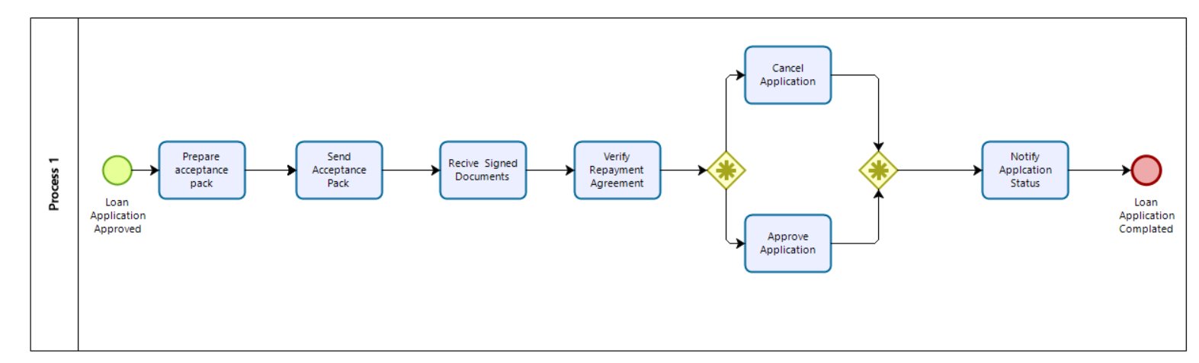

Figure 2.1: Task 1

Task details shown below in steps:

Step 1. If the loan application is approved, the acceptance package is prepared.

Step 2. Acceptance pack sends.

Step 3. Signed documents receiving.

Step 4. Repayment agreement verifies.

Step 5. If the applicant disagreed with the repayment schedule, the loan provider cancels the application; if the applicant agreed, the loan provider approves the application.

Step 6. Notifying application status to the applicant.

Step 7. At the last step loan application completing.

## 2.2 TASK 2

In this subsection is shown to draw a business process using BPMN to evaluate loan applications.

Task is drawn on the following information;

First, the loan application must go through two checks to be approved: The first check is the applicant's automatic credit risk assessment by a system, and the second is the assessment of the property where the loan performed by a property appraiser is requested. The risk assessment requires a credit history check performed by a financial officer on the applicant. After both a credit risk assessment and a property assessment, a loan officer determines the eligibility of the applicant. If the applicant is not eligible, the application is rejected, otherwise the acceptance package is prepared and sent to the applicant. Task 2 is shown Figure 2.2.

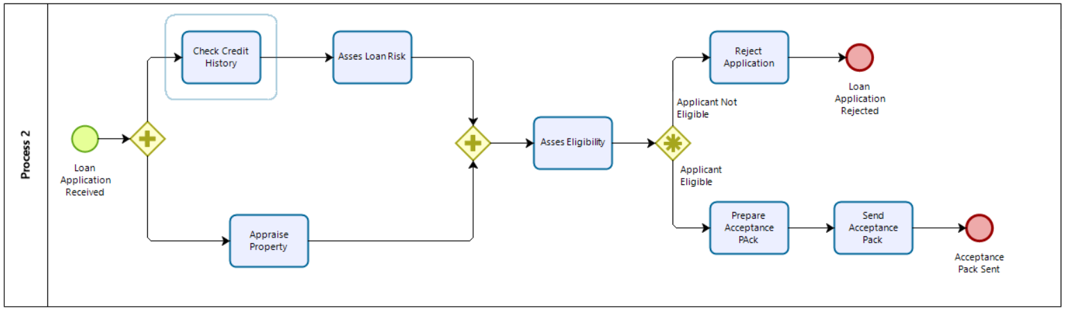

Figure 2.2: Task 2

Task details shown below in steps:

Step 1. If the loan application is approved, there is 2 check available first one is the applicant’s loan risk assessment, done automatically by a system second one is the applicant’s loan risk assessment, done automatically by a system.

Step 2. In the asses eligibility task, a loan officer can assess the applicant’s eligibility.

Step 3. If the applicant is not eligible, the application is rejected otherwise, the acceptance pack is prepared and sent to the applicant.

**CHAPTER THREE**

**TASK 3 – TASK 4**

How to do task 3 and task 4 and their details are explained under this chapter.

## 3.1 TASK 3

Home owners insurance is also important when buying a house. This is usually required before a loan or mortgage is approved. The house insurance is expected to cover the full cost of building the house, any additional structures around the house as well as all the possessions contained in the house. The loan provider may also offer different kinds of home insurance policies at discounted prices. The process around this as shown in the model is as follows:

Steps:

1. The financial officer sends the loan application for approval to the loan officer.
2. The loan officer then checks for completeness if it is not complete it is sent back to the applicant for completion, if it is complete an Acceptance Pack is prepared.
3. Acceptance pack is prepared - the applicant is offered home insurance quotes at discounted rates from the institution
4. If applicant shows no interest in the home insurance quotes- only Acceptance Pack is sent to applicant, and waits for applicant’s decision
5. If applicant shows interest in the home insurance - both Acceptance Pack and Home insurance quote are sent to the applicant
6. The institution then waits for the Acceptance Decision - which will lead to repayment schedule creation and agreement

## 3.2 TASK 4

When an applicant requires a loan, they make an application at the loan provision institution. Various checks are conducted during the application process such as credit history, risk analysis as well as completeness. These checks are usually done by the Financial Officer who then forwards the information to the loan provider. The loan provider then proceeds to check for Completeness according to their stipulated requirements. In the case that the application is incomplete, it is sent back to the Applicant. , to check ,correct and make additions where needed before resubmitting it again for verification by the loan provider . This may be done several times until the desired outcome is reach and an Acceptance Pack can be sent to the applicant.

Steps:

1. Financial officer sends loan application to loan provider for approval and completeness check.
2. Loan provider carries out completeness check.
3. If it is Incomplete it is sent back to Applicant for completion.
4. Applicant receives incomplete application
5. Fills out application and sends it back to the Loan provider
6. Loan provider receives updated and corrected loan application
7. loan provider carries out completeness check

-if it is incomplete it is sent back to Applicant for completion and repeat steps 3 to 7

-if it is complete an Acceptance pack is prepared and sent out

The completeness check can be repeated several times until the application is filled completely with all required fields such as name and address field are properly filled.

**CHAPTER FOUR**

**TASK 5– TASK 6**

How to do task 5 and task 6 and their details are explained under this chapter.

## 4.1 TASK 5

How to do task 5 and task 6 and their details are explained under this chapter.

Combining all other works proved tricky as paying close attention to how the ending of a process in one lane is the beginning of a process in another lane, having gotten all the other diagrams comes the challenge of combining them into a more well diagram and understandable BPMN diagram in order to do that various start BPMN icons/A were used the show the relationship between various lanes in and outside the organization. Firstly, using a message flow to show the relationship or the flow of messages between 2 participants that can send and receive them. Combination of task 1-4 shown Figure 5.1.

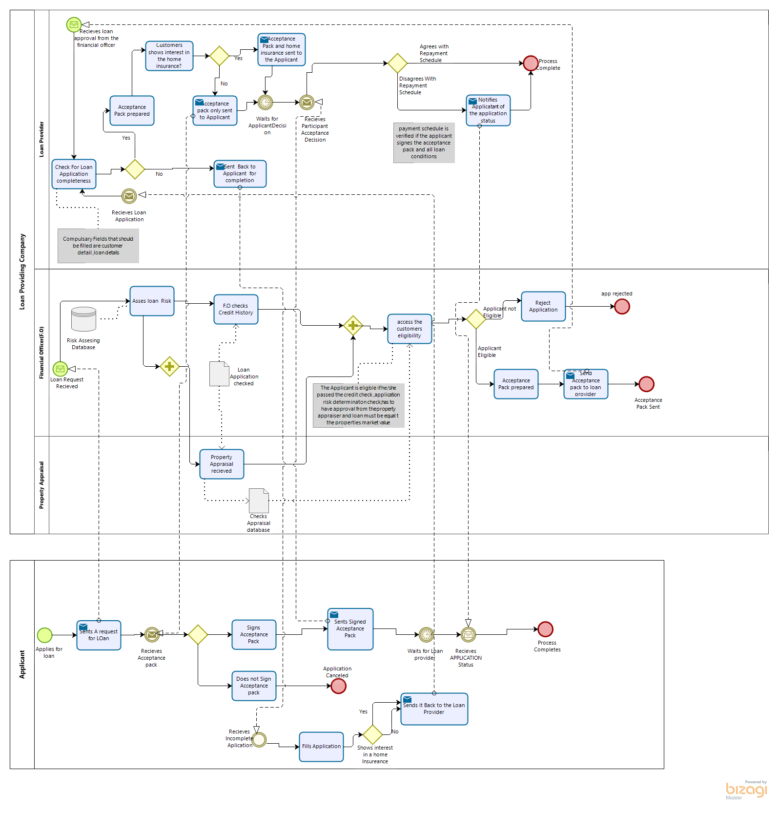

Figure 5.1: Combination of Task 1-4

Message flow symbol shown in figure 5.2

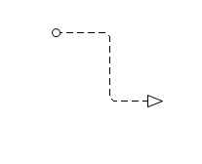

Figure 5.2: Message Flow Symbol

By using a message flow symbol work can be track to various lanes as stated before.

As stated, before some end process in one lane can be the starting process in another lane this can be spotted for example between the financial office and the loan provider if the

Annotations: This was used to organize text and sub processes or to add comment describing a particular process element. it was also used to explain the business rules governing a particular aspect in the BPMN Diagram. Annotation symbol shown in Figure 5.3.

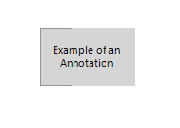

Figure 5.3: Annotation Symbol/Example

After using the above symbols/annotation to explain and show the relationship between various lanes in the organization we get a well detailed and easy to read diagram.

## 4.2 TASK 6

The loan officer is the main point holding all other process together, in the business organization, all processes from other lane/aspect of the organization must go through the loan officer, taken this into consideration while extending all business process between the Loan officer and the property appraisal, loan officer and the finical officer, loan officer and the applicant this is done by extending the business process of these lanes and showing how various steps are in connection with the loan officer.Addition of the Property Appraisal Lane to Show an Extended Business Process is shown Figure 5.4.



Figure 5.4: Addition of the Property Appraisal Lane to Show an Extended Business Process.

**CHAPTER FIVE**

**TASK 9 – TASK 10**

How to do task 9 and task 10 and their details are explained under this chapter.

## 5.1 TASK 9

While the challenges faced by insurance companies are similar to those encountered in all other sectors, insurers particularly focus on increasing cost effectiveness and to management risk. Insurance companies should focus on customer satisfaction to increase their market share. It is important that basic IT systems that support insurance transactions or processes are simplified, agile and flexible. Insurers use BPM technology to bring agility to IT systems and overcome other industry challenges [2].

Task 9 is a business process for insurance claims.

**Steps**

1. Registered claim is the beginning of the process flow. The element used for this is "start event".
2. Registered claim is connect to the examination by claim officer as a "task". The sequence flow is used for the connect between elements.
3. A recommendation is written as a "second task".
4. The recommendation written is examined by senior claims officer. The element used for this process is gateway (decision).
5. If the senior claim officer mark the claim as "OK", the claim handling is processed and the process is completed. The element used for this is "end event".
6. If the senior claim officer mark the claim as "Not OK", the claim is sent back as a "new task" to the examination by claim officer and the recommendation is repeated.

Insurance companies differentiate with BPM, increasing their market share and profitability. By applying BPM, they can become more advantageous than other companies in the market.

## 5.1 TASK 10

In most cases, finance departments need the same support as other departments of a business. Ensuring that workflows and processes are optimized in the same way as other departments will ensure smooth operations. Investing in high-quality business process software is required to unlock the true potential of financial services [3].

Processes such as assessment of credit risks can be met with BPM software.

Credit risk is:

Risk of default:The risk that a counter party will be unable to perform as agreed.

Risk of loss:The risk that as a result of a counter party's inability to perform as agreed, the lender suffers a loss.

Task 10 is a business process for assessing credit risks.

Steps

1. Credit request (risk) is received. The element used for this is "task". Then, the task connected to another task. The sequence flow is used for the connect between elements.
2. Credit request (risk) is assessed. Assessment is based on risk threshold status. And the threshold status is divided two task.
3. If the risk is below the threshold, simple risk assessment is made.
4. If the risk is above the threshold, complex risk assessment is made.
5. After the risk assessment, disbursement is organized.
6. Customer is notified, as a result of the assessment.

The firm's accounts are managed and regulated more efficiently. Efficiency is optimized.

**CONCLUSION**

Corporate Process Management (Business Process Management) is a method that handles the work done within the company with a holistic approach in order to model how businesses do their jobs. BPM aims to reveal the processes that can be counted among the assets of the enterprises, document them, make improvements and make the steps automatic. BPM, which is also associated with financial matters of high level of importance for businesses, enables the performance of the process costs and individuals to follow up the performance of the process easily by revealing the performance criteria.

In this project, business processes are determined using business process notation.

**REFERENCES**

[1] W.M. P Van Der Aalst, A.H.M Hofstede and M. Weske,” Business Process Management: A Survey: A Survey,”Proc.Ist Int.Conf.Bus.Process Manag.,pp.1-12,2003

[2] Capgemini Italia. 2020. *Business Process Management for Insurance*. [online] Available at: <https://www.capgemini.com/it-it/resources/business-process-management-for-insurance/> [Accessed 29 June 2020].

[3] Ross, M., 2020. *3 Advantages of BPM for Financial Services - Appian Blog*. [online] Appian Blog. Available at: <https://www.appian.com/blog/3-advantages-of-bpm-for-financial-services/> [Accessed 29 June 2020].